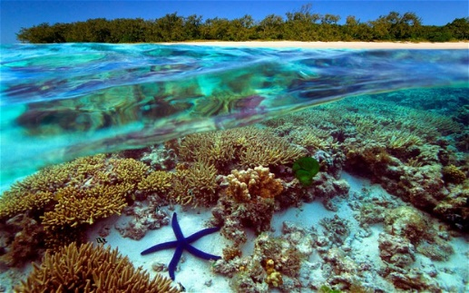 ***Seven Themes of Geography: Group Task***

*Geographers use seven concepts to help investigate and understand the world. As you learn to use each of these key ideas you will begin to think like a geographer. The seven key concepts in Geography are:*

**Group Task:**

* In table groups of 3 -4 (this will depend on your class size) break students up into 7 groups.
* Each group will be responsible for investigating one of the seven **SPICESS** concepts.
* Print out the concepts on large A3 paper or use butchers paper for groups to write on.
* Allow the groups sufficient time to write their responses, (this will vary on the age and ability of your students)
* Each group then reports back to the rest of the class their findings.
* When the group presents have them pin their sheet up on the board, where other students can see.
* Use the groups presentations to generate discussion.

**Note:** You should find this works really well at generating discussion and reinforcing the concepts.

***S:*** *Space*

***P:*** *Place*

***I:*** *Interconnection*

***C:***  *Change*

***E:*** *Environment*

***S:*** *Sustainability*

***S:*** *Scale*

**Space: *The concept of space is about the way things are arranged on the earth’s surface.* *It has three main elements:***

* ***Location*** *- where things are located on the Earth’s surface*
* ***Spatial distribution*** *– the shapes and patterns in which things are arranged on the earth’s surface*

**Place:**

*The concept of place is about the significance of places and what they are like. Your home and your school are important places for you because they are the places where you live and spend most of your time. A place can be as small as your bedroom or as large as the entire planet!*

**Interconnection:**

*No place or thing on earth exists in isolation. Interconnection is the ways that the people and things are connected with each other, and the consequences of these interconnections.*

**Change:**

*Change is about investigating how places and spatial patterns change over time in the short and long term.*

**Environment:**

*The concept of environment is about how people rely on, use and change the physical and biological world around us.*

**Sustainability:**

*Sustainability is using the environment and resources so they can be shared by all people and living creatures now and into the future.*

**Scale:**

*The concept of scale is about the way that geographical issues and problems can be examined at different spatial levels – local, regional, national, international of global*.